Chapter 5
Implementation

  - Implementation Planning

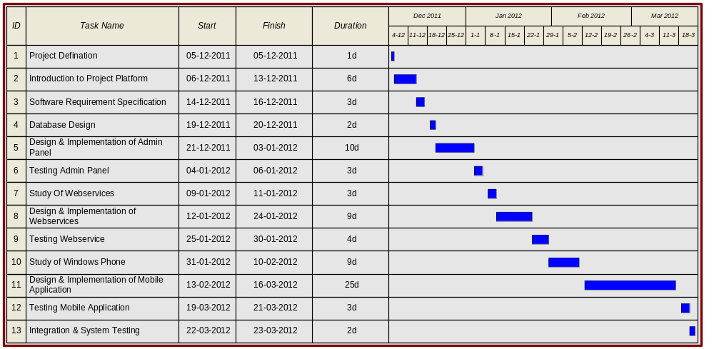

Table 5.1 : Implementation Planning

  - Implementation Pattern

MVVM Overview

The Model View ViewModel (MVVM) is an architectural pattern used in software engineering that originated from Microsoft as a specialization of the Presentation Model design pattern introduced by Martin Fowler. Model-View-ViewModel (MVVM) pattern splits the User Interface code into 3 conceptual parts - Model, View and ViewModel out of which the concept of the ViewModel is the new and the most exciting.

- Model is a set of classes representing the data coming from the services or the database.
- View is the code corresponding to the visual representation of the data the way it is seen and interacted with by the user.
- ViewModel serves as the glue between the View and the Model. It wraps the data from the Model and makes it friendly for being presented and modified by the view. ViewModel also controls the View's interactions with the rest of the application (including any other Views).
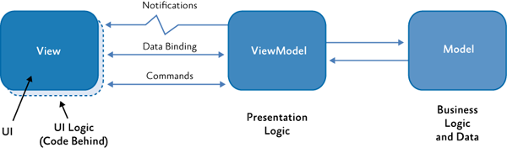

Figure 5.1 : Simple MVVM Architecture

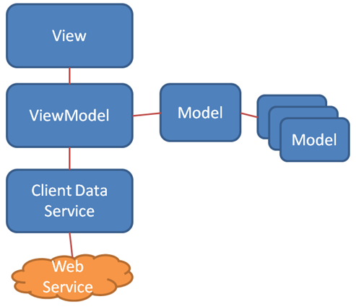

Figure 5.2 : MVVM Architecture with Web services

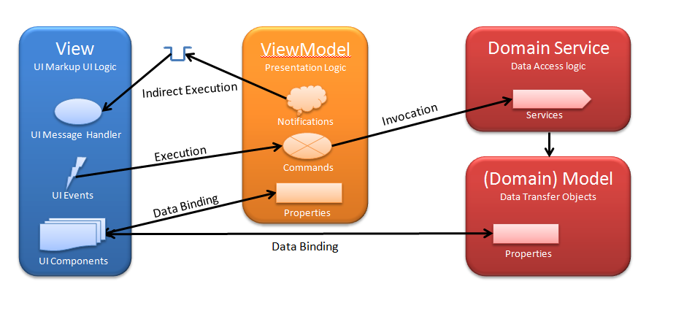

Figure 5.3 : Detailed MVVM Architecture

Benefits of MVVM :

- Separates UI from Model. If model needs to change, it can without changing the view and vice versa.
- Avoids duplicated code to update views.
- Unit testable UI logic.
- Databinding support with INotifyPropertyChanged, ICommand and IvalueConverters
- Reusability
- Extensibility

  - Implementation Methodology

A software implementation method is a systematically structured approach to effectively integrate software based service or component into the workflow of an organizational structure or an individual end-user.

    - Object Oriented Methodology

We live in a world of objects. These objects exist in nature, in man-made entities, in business, and in the products that we use. They can be categorized, described, organized, combined, manipulated and created. Therefore, an object-oriented view has come into picture for creation of computer software. An object-oriented approach to the development of software was proposed in late 1960s.
Object-Oriented development requires that object-oriented techniques be used during the analysis, and implementation of the system. This methodology asks the analyst to determine what the objects of the system are, how they behave over time or in response to events, and what responsibilities and relationships an object has to other objects. Object-oriented analysis has the analyst look at all the objects in a system, their commonalties, difference, and how the system needs to manipulate the objects.
The Object Oriented Methodology of Building Systems takes the objects as the basis. For this, first the system to be developed is observed and analyzed and the requirements are defined as in any other method of system development. Once this is done, the objects in the required system are identified.
In simple terms, Object Modeling is based on identifying the objects in a system and their interrelationships. Once this is done, the coding of the system is done. Object Modeling is somewhat similar to the traditional approach of system designing, in that it also follows a sequential process of system designing but with a different approach.

The basic steps of system designing using Object Modeling may be listed as:
- System Analysis
- System Design
- Object Design
- Implementation

- Advantages of Object Oriented Methodology

- Object Oriented Methodology closely represents the problem domain. Because of this, it is easier to produce and understand designs.
- The objects in the system are immune to requirement changes. Therefore, allows changes more easily.
- Object Oriented Methodology designs encourage more re-use. New applications can use the existing modules, thereby reduces the development cost and cycle time.

Object Oriented Methodology approach is more natural. It provides nice structures for thinking and abstracting and leads to modular design.

    - Prototyping Model

The Prototyping Model is a Software Development Life Cycle (SDLC) in which a prototype (an early approximation of a final system or product) is built, tested, and then reworked as necessary until an acceptable prototype is finally achieved from which the complete system or product can now be developed. This model works best in scenarios where not all of the project requirements are known in detail ahead of time. It is an iterative, trial-and-error process that takes place between the developers and the users.

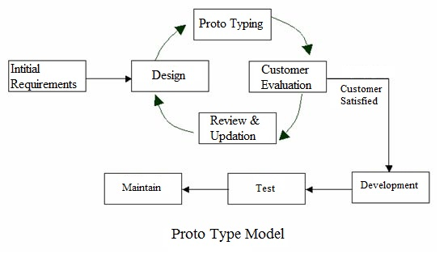

Figure 5.4 : Proto Type Model

There are several steps in the Prototyping Model:

- The new system requirements are defined in as much detail as possible. This usually involves interviewing a number of users representing all the departments or aspects of the existing system.

- A preliminary design is created for the new system.
- A first prototype of the new system is constructed from the preliminary design. This is usually a scaled-down system, and represents an approximation of the characteristics of the final product.
- The users thoroughly evaluate the first prototype, noting its strengths and weaknesses, what needs to be added, and what should to be removed. The developer collects and analyzes the remarks from the users.
- The first prototype is modified, based on the comments supplied by the users, and a second prototype of the new system is constructed.
- The second prototype is evaluated in the same manner as was the first prototype.
- The preceding steps are iterated as many times as necessary, until the users are satisfied that the prototype represents the final product desired.
- The final system is constructed, based on the final prototype.
- The final system is thoroughly evaluated and tested. Routine maintenance is carried out on a continuing basis to prevent large-scale failures and to minimize downtime.

Another reason for developing a prototype is that it is impossible to get the perfect product in the first attempt. Many researchers and engineers advocate that if you want to develop a good product you must plan to throw away the first version. The experience gained in developing the prototype can be used to develop the final product.

  - Coding Standards

To make the system coding easy, easy to remember and reducing the chances of errors some techniques are used at the time of coding of the application which is called coding system. The coding system which we adopted during the coding is explained as follows:

- File names follow Pascal Casing where First characters of all words are in upper case and other characters are in lower case.

Every file name has a suffix View,ViewModel or Model.
Example: SignInView.xaml
SignInView.xaml.cs
SignInViewModel.cs
SignInModel.cs

- Method names are written in lower case and are separated by underscore (“_”)

Example : signin_button_click()

- Variable names follow Camel Casing where First characters of all words, except the first word are in upper case and other characters are in lower case.

Example: isProgressBarVisible

UI Control Naming Convention:
Control | Suffix | Example
Label | _label | error_label
TextBox | _textbox | username_textbox
TextBlock | _textblock | username_textblock
Button | _button | signin_button
ImageButton | _button | edit_button
Hyperlink | _link | signup_link
DropDownList | _dropdown | year_dropdown
GridView | _gridview | user_gridview
Checkbox | _checkbox | rememberme_checkbox
RadioButtonList | _radiobuttonlist | iseditable_radiobuttonlist
Image | _image | location_image

Table 5.2 : UI Control Naming Convention

